Tenant Move-In Procedure on Different Dates SOP
Objective
This SOP outlines the steps to manage tenant move-in dates that differ from the standard lease start date, ensuring all necessary adjustments are made in the system.
Key Steps
Step 1: Access the Prospect Page 0:00
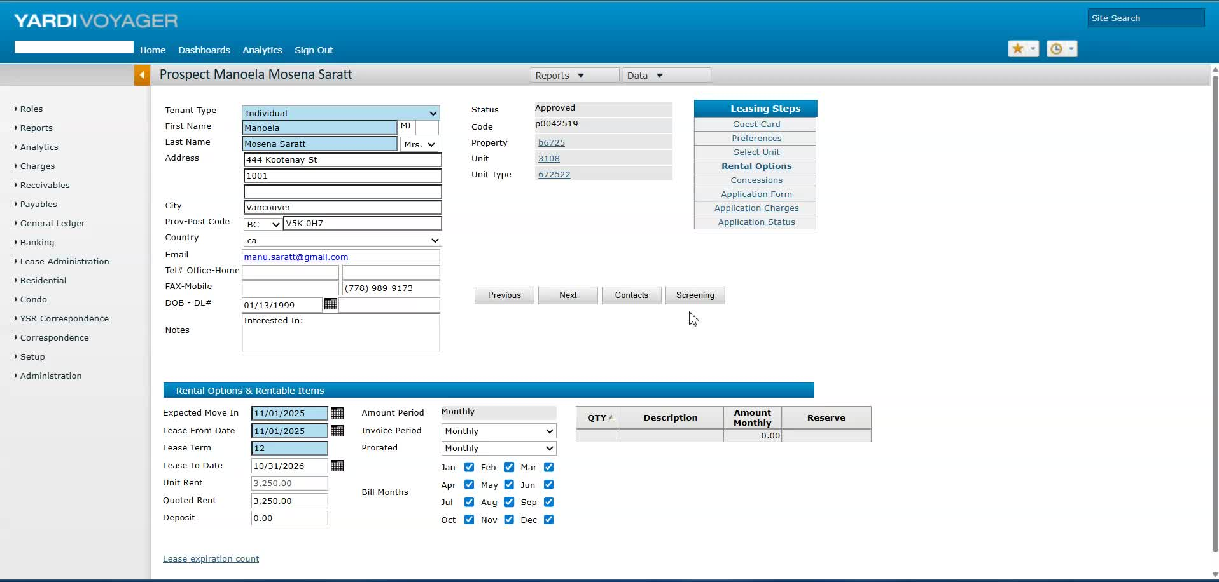
- Navigate to the prospect page in the system.
- Confirm the tenant's approved move-in date (e.g., November 15th for Manola and Matthew).
Step 2: Check System Lock Status 0:28
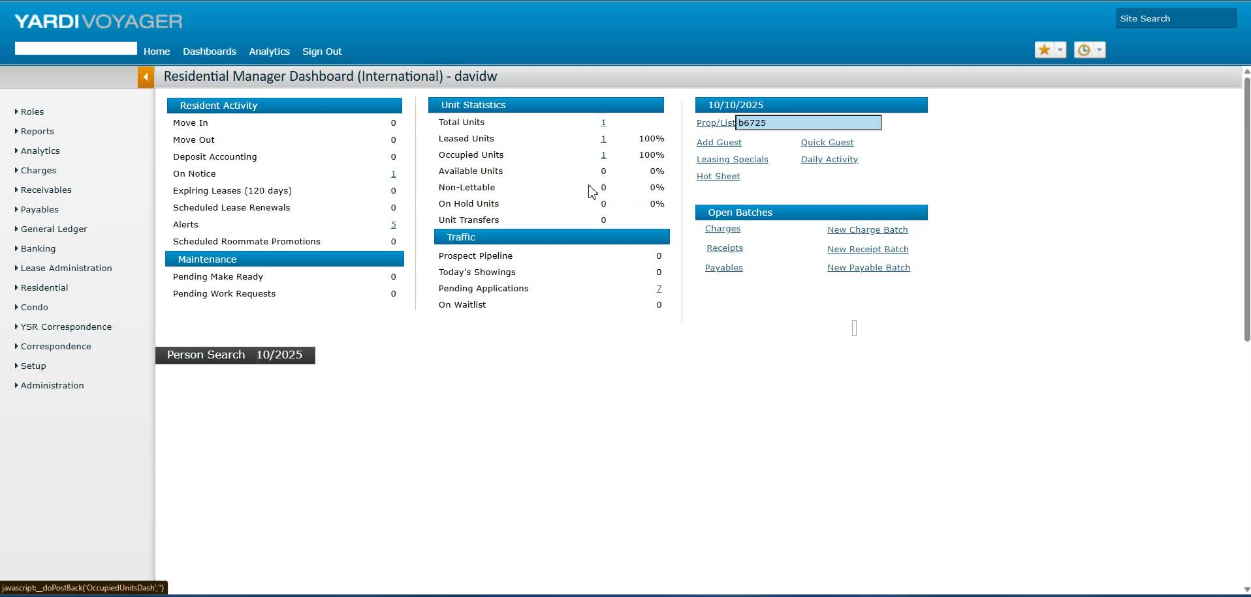
- Verify if the back office is locked.
- Note that changes cannot be made if the back office is locked.
Step 3: Navigate to Pending Applications 0:42
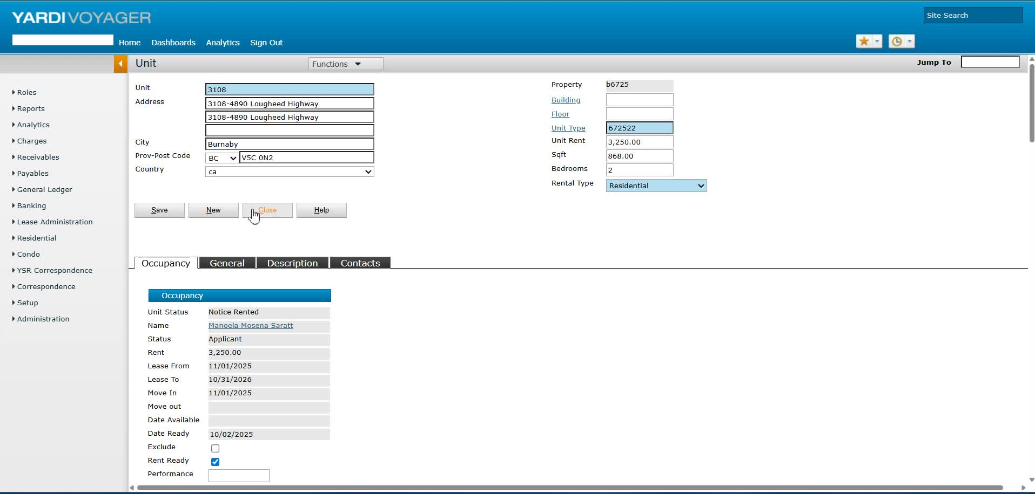
- Go to the property page.
- Select 'Pending Applications' to access the relevant tenant application.
Step 4: Update Move-In and Lease Dates 0:54
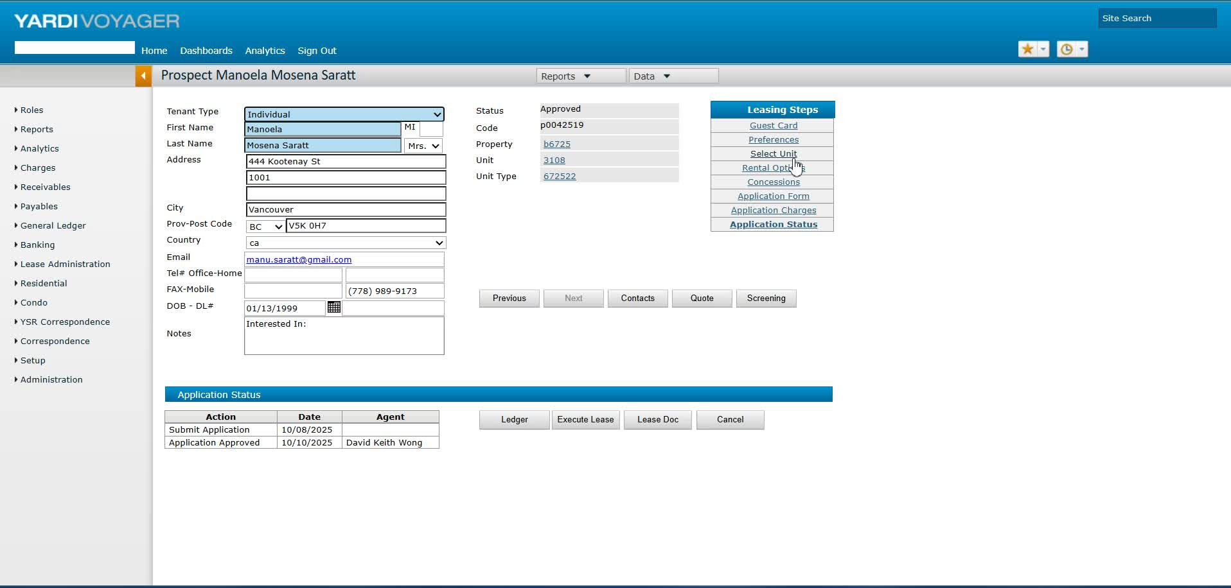
- In the rental options, set the expected move-in date to November 15th.
- Set the lease end date to November 30th of the same year.
Step 5: Confirm Rent Payment Terms 1:08
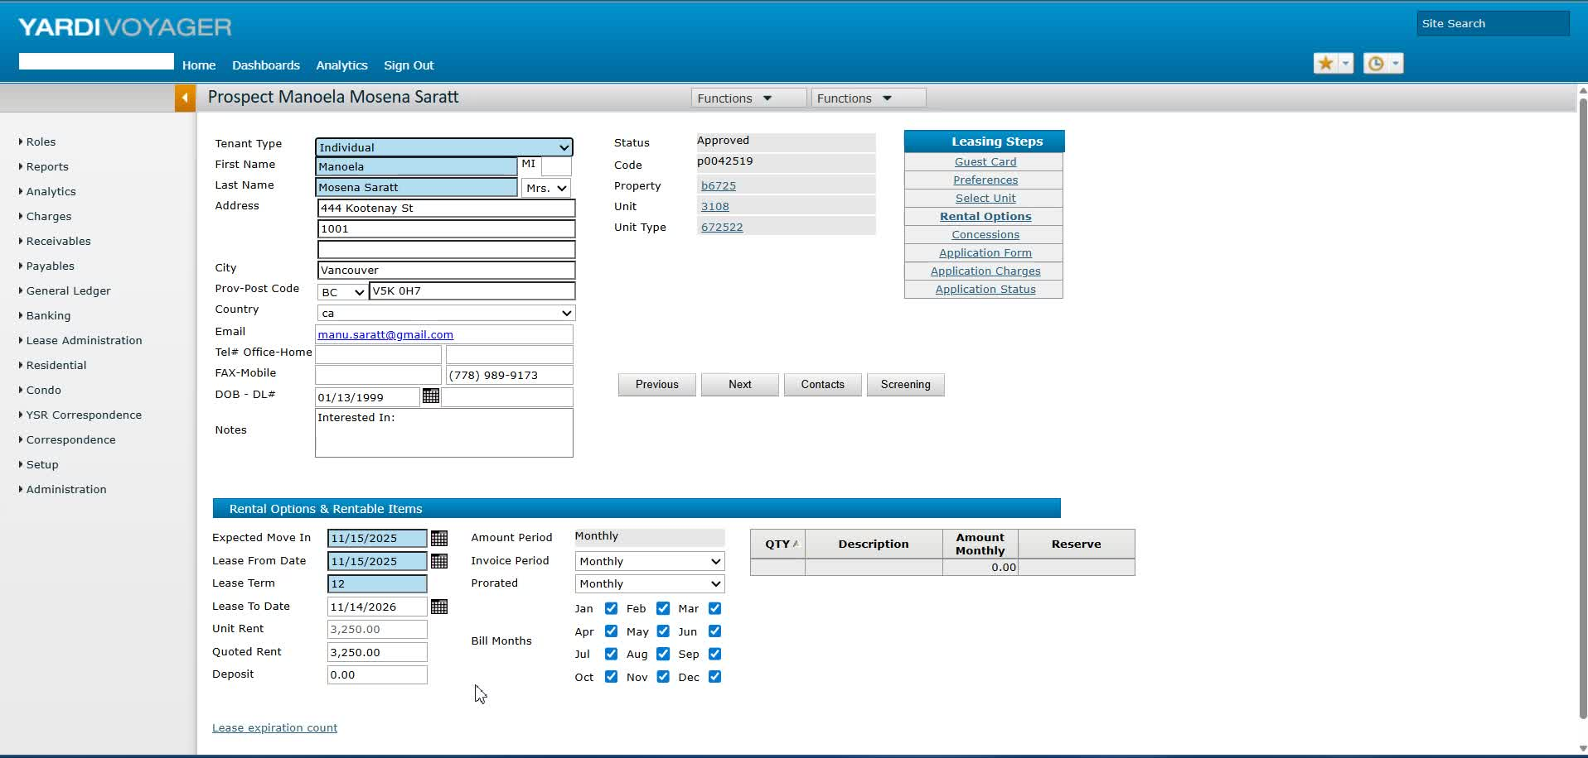
- Ensure that the tenant is aware they will pay the full month of November rent regardless of the move-in date.
Step 6: Review Application Charges 2:00
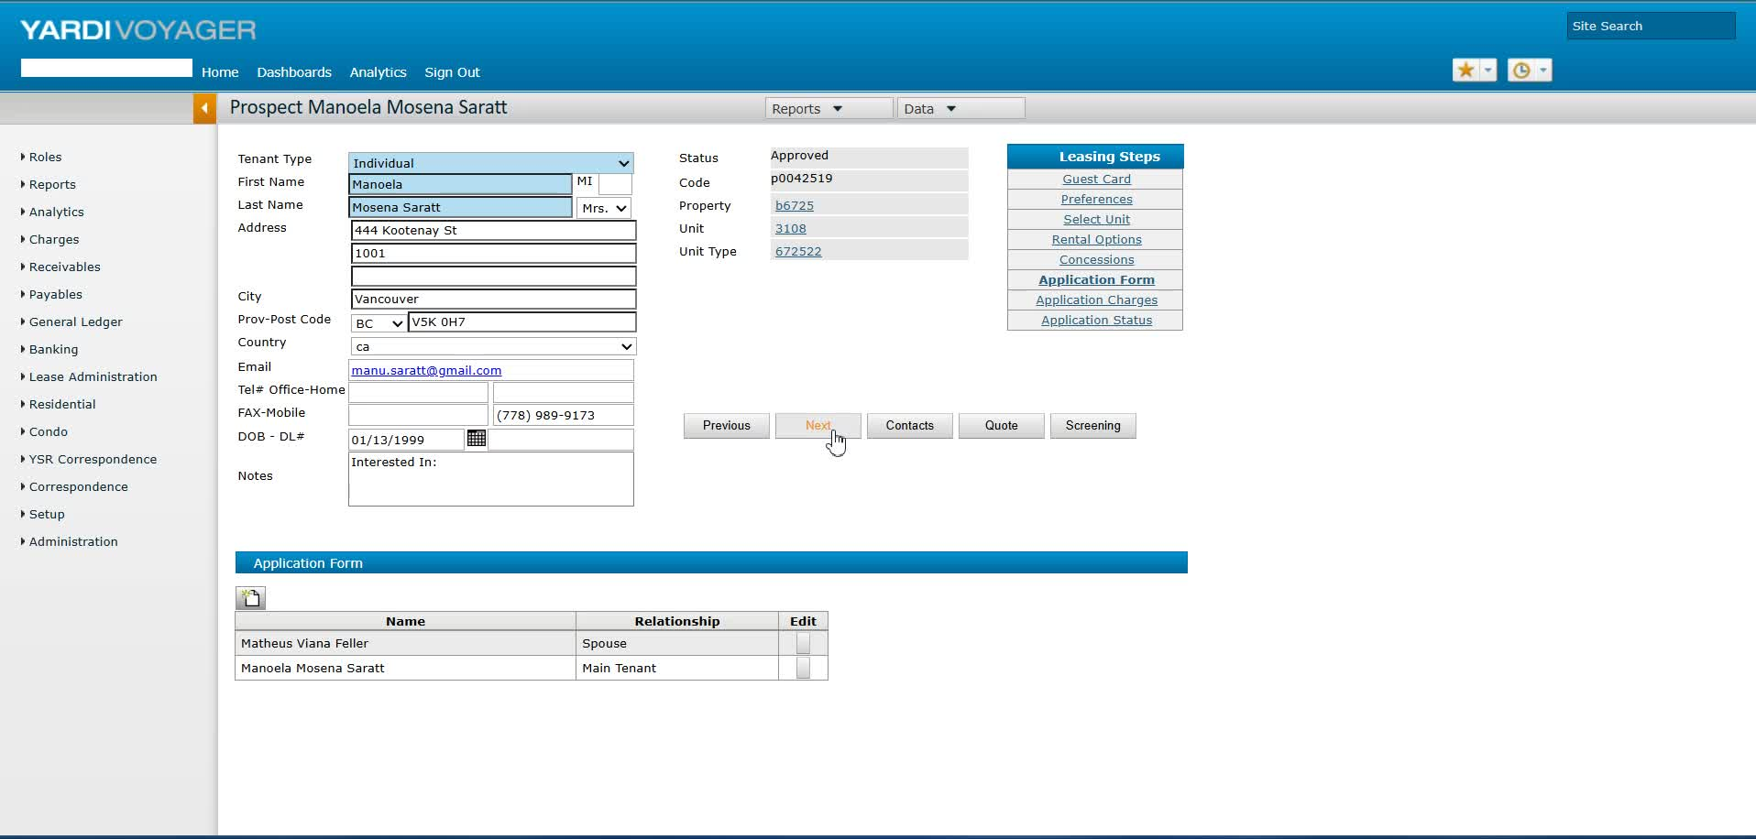
- Check the application charge details to ensure accuracy before generating the tenancy agreement.
Step 7: Verify Tenant Information 2:33
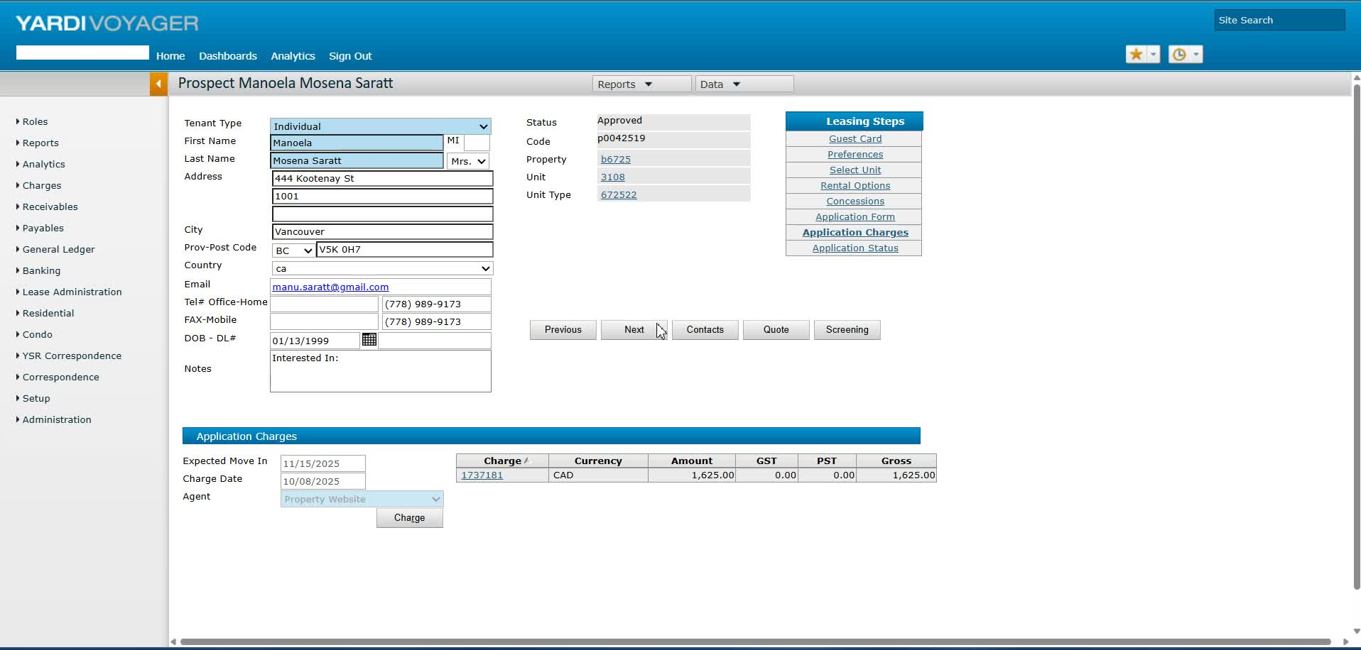
- Confirm that all tenant information, including phone numbers, is correctly saved in the system.
Step 8: Access RENCAFE for Updates 3:08
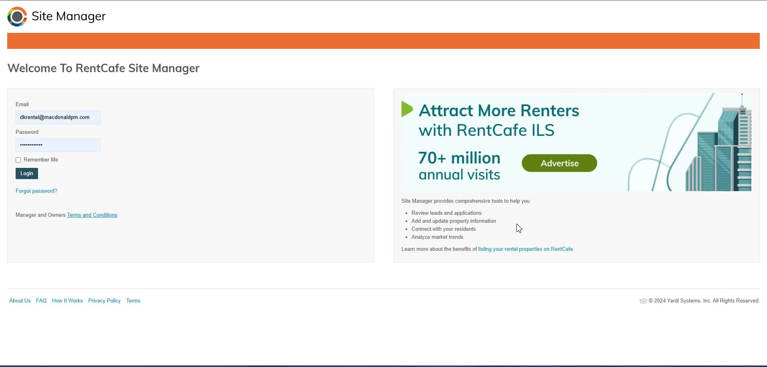
- Launch RENCAFE and access the tenant's profile.
- Ensure that the move-in date reflects the updated date.
Step 9: Generate Tenancy Agreement 4:00
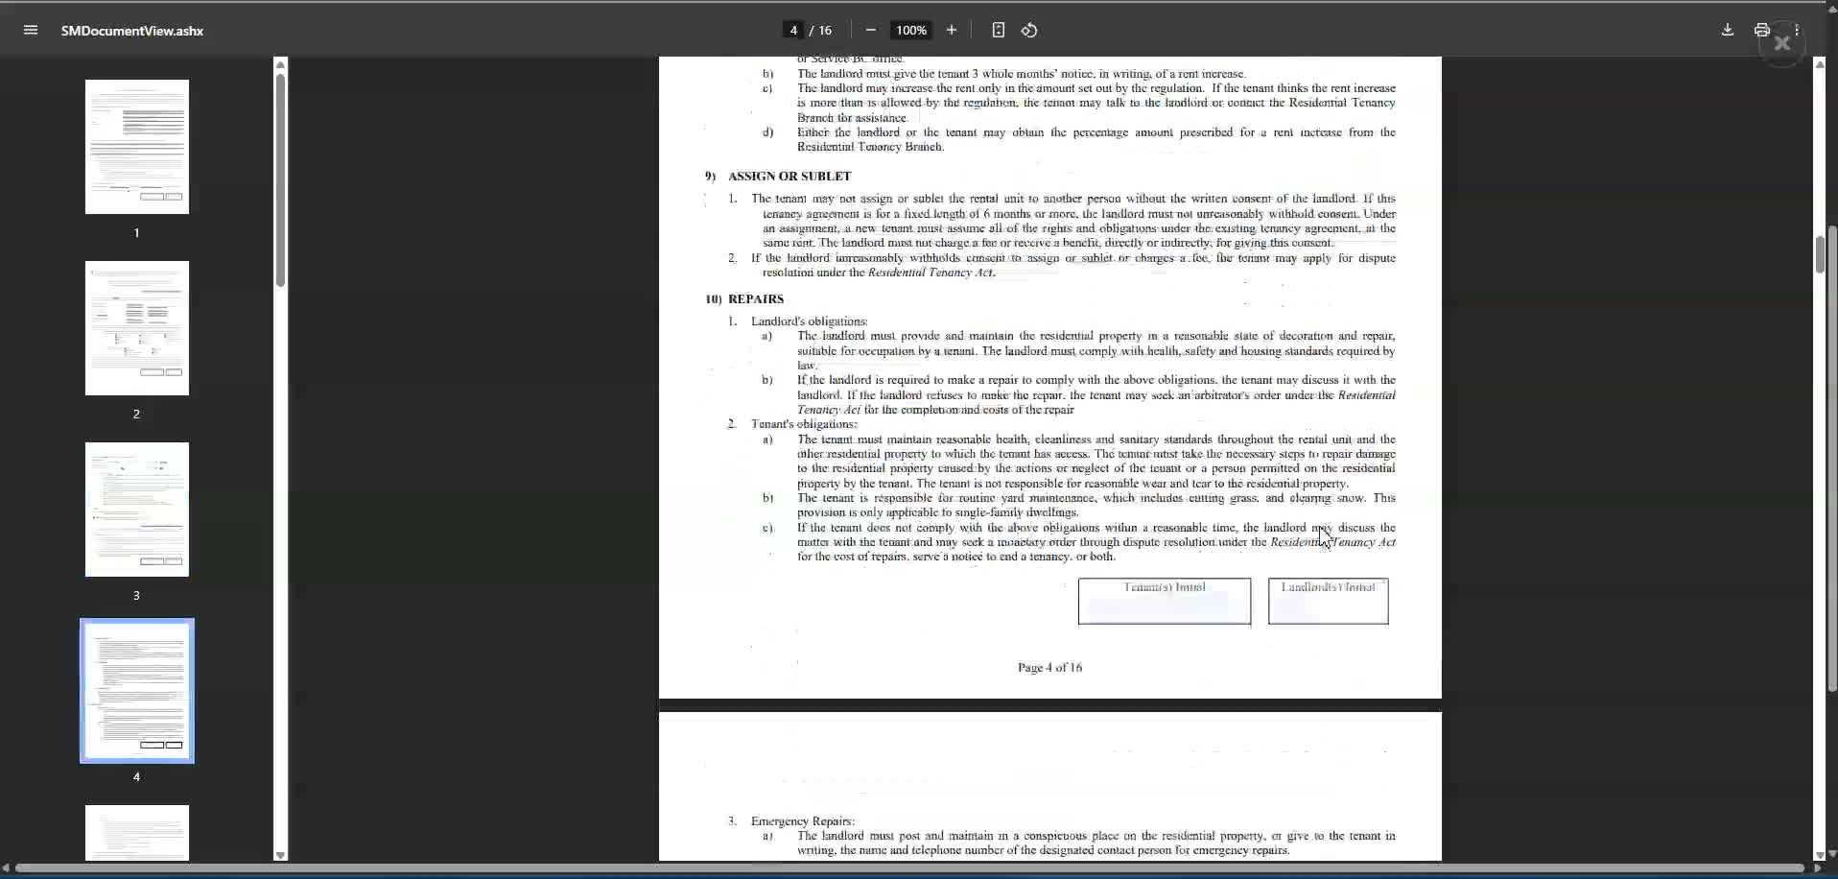
- Generate the tenancy agreement ensuring all details are correct, including phone numbers and email addresses.
Step 10: Final Review and Save 5:08
- Conduct a final review of all documents, including parking and storage agreements.
- Save all documents in the designated subfolder for signature preparation.
Cautionary Notes
- Always double-check tenant information for accuracy before finalizing documents.
- Ensure that the back office is not locked before attempting to make changes.
Tips for Efficiency
- Use templates for tenancy agreements to save time.
- Regularly update tenant information to avoid discrepancies during the process.
Link to Loom
https://loom.com/share/d0b7b718db7b45a1a4c7c500ff9cdaff
Tenant Move-In Process for November 15th
1. Identify Tenant Move-In Date 0:00

- Confirm the tenant's approved move-in date (e.g., November 15th for Manola and Matthew).
- Note that no need to contact Brenda for changes.
2. Access the Prospect Page 0:13
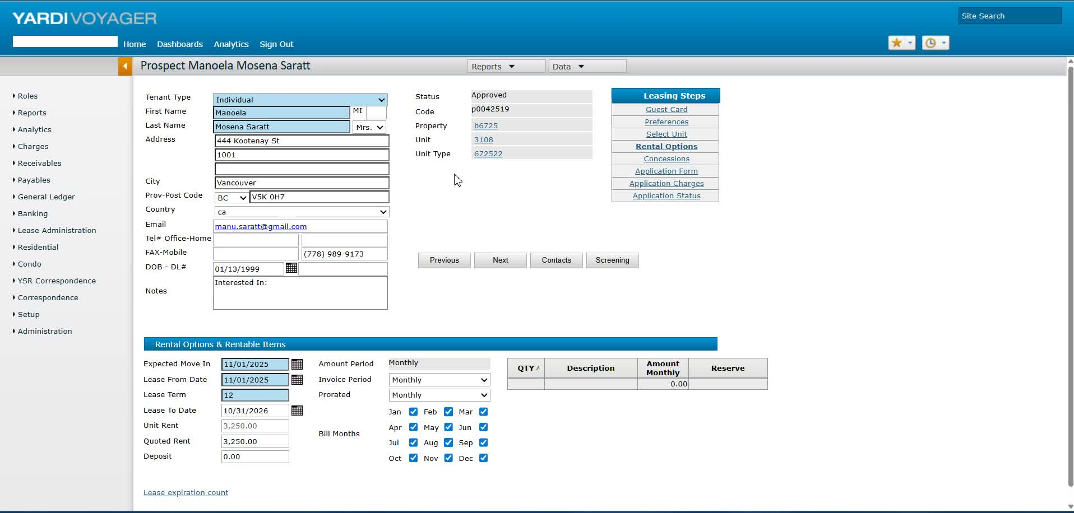
- Navigate to the home page and access the prospect page.
3. Check for Changes in Yardy 0:28

- Understand that changes cannot be made directly if the back office is locked.
- Only light changes can be made.
4. Go to Pending Applications 0:42

- Access the pending applications section since the tenancy agreement has not been generated yet.
5. Update Rental Options 0:54

- Select the unit and update the expected move-in date to November 15th.
- Set the lease date to November 30th, as tenants pay for the full month regardless of move-in date.
6. Review Deposit and Charges 1:30
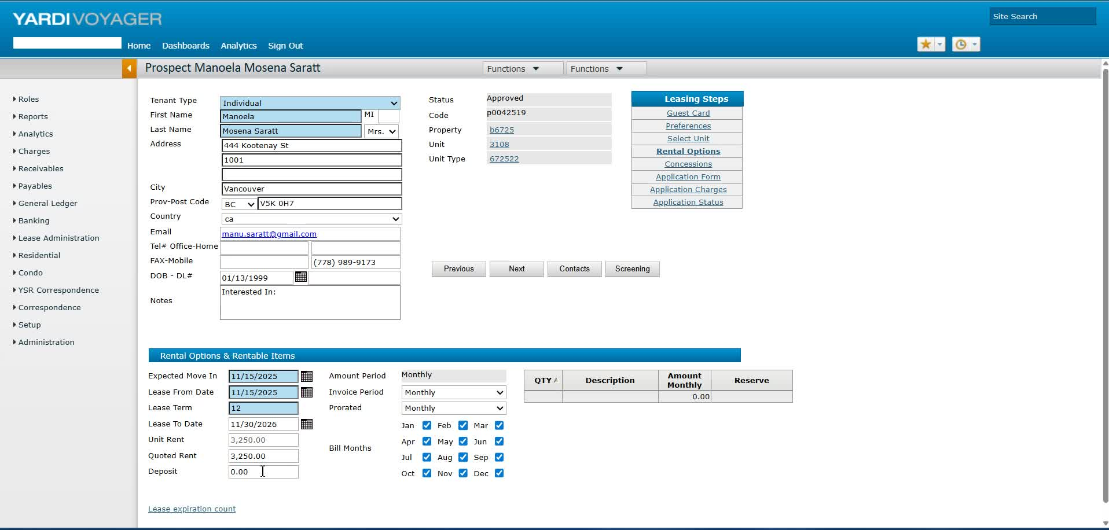
- Note that the deposit information may not be significant at this stage.
7. Confirm Application Details 1:59
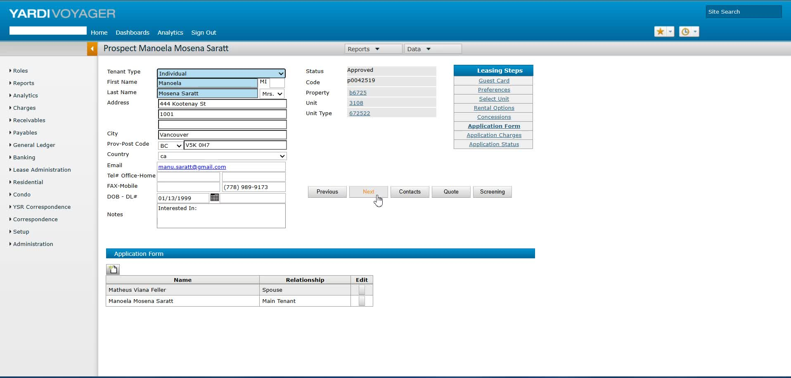
- Check the application charge and ensure all details are correct before generating the tenancy agreement.
8. Verify Contact Information 2:16
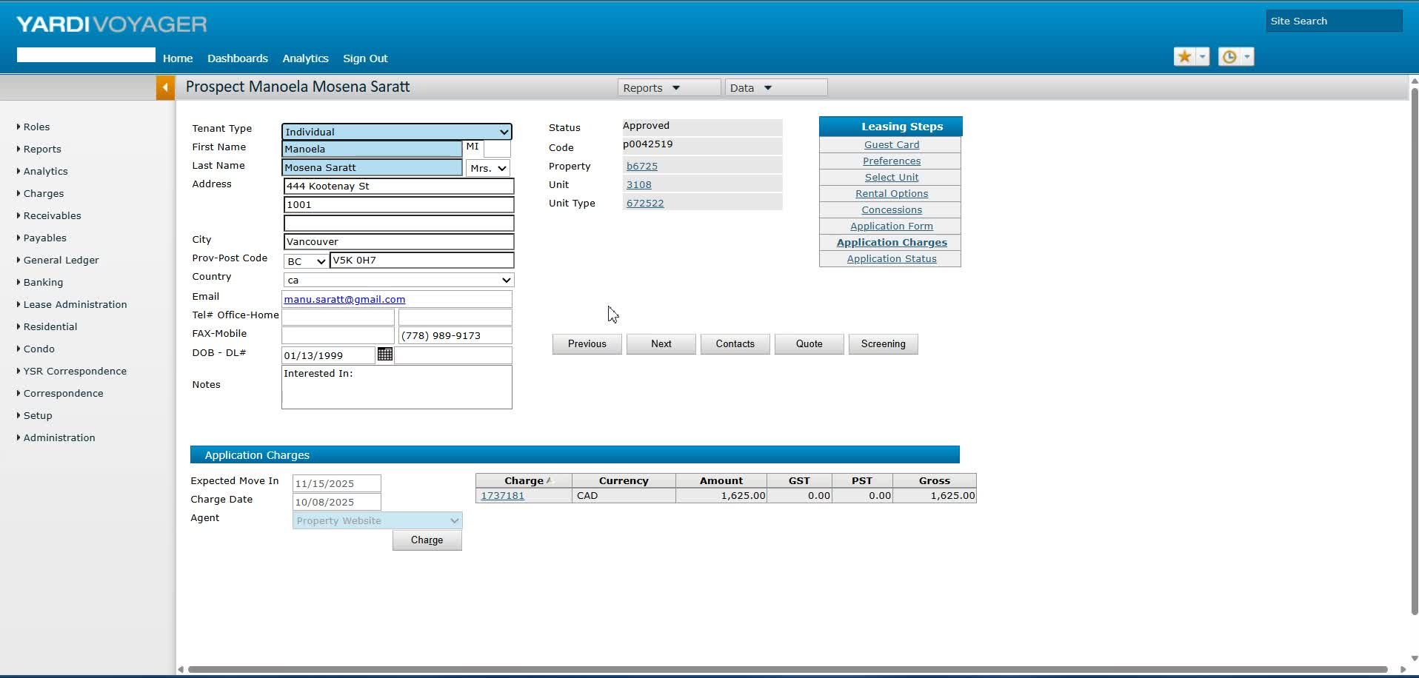
- Ensure phone numbers are correctly displayed, as there may be issues with mobile numbers.
9. Save Tenant Information 3:04
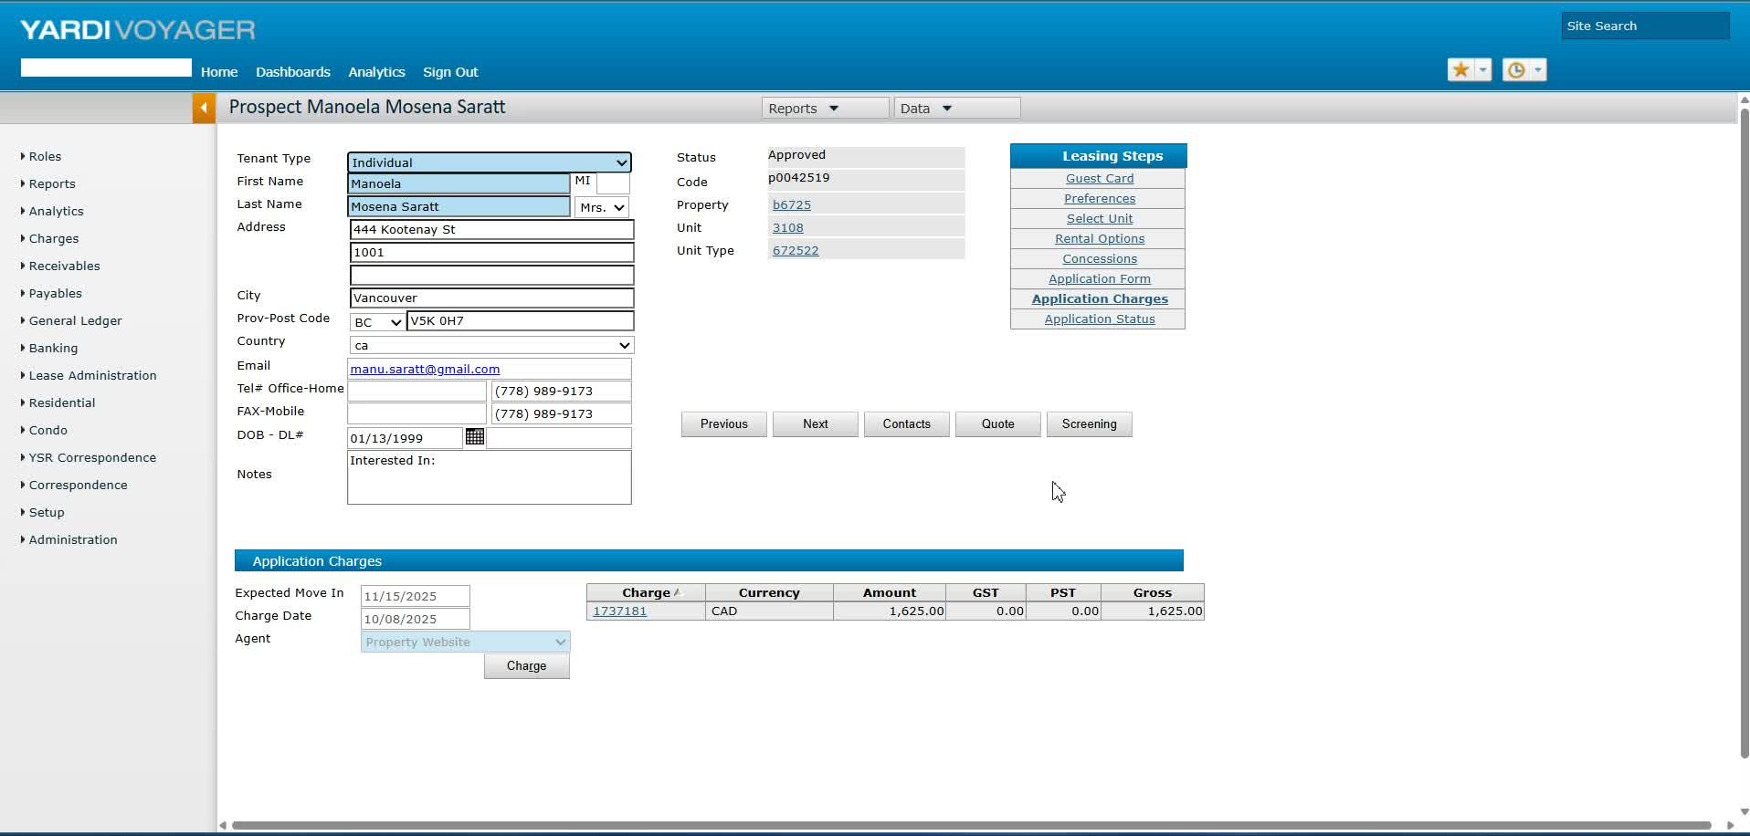
- Save the tenant's information to ensure it is locked in.
10. Access RENCAFE for Updates 3:18
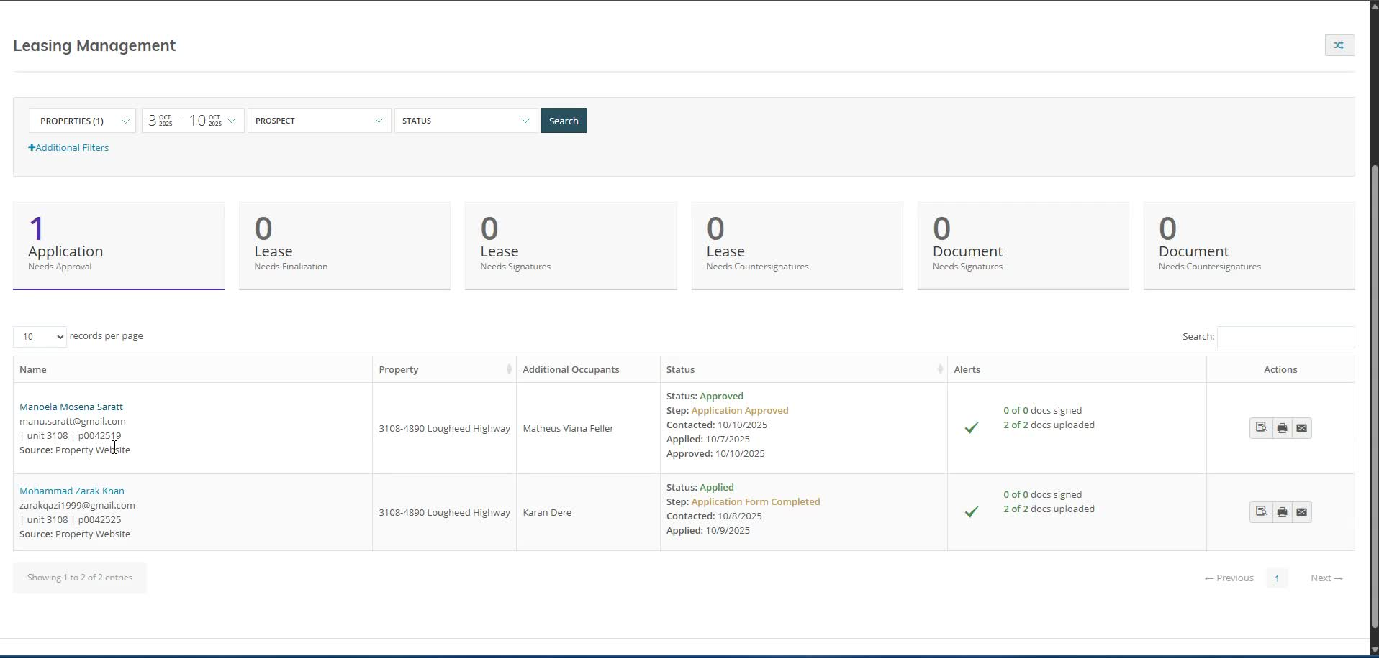
- Launch RENCAFE and check that the move-in date has updated to the 15th.
11. Generate Tenancy Agreement 3:36
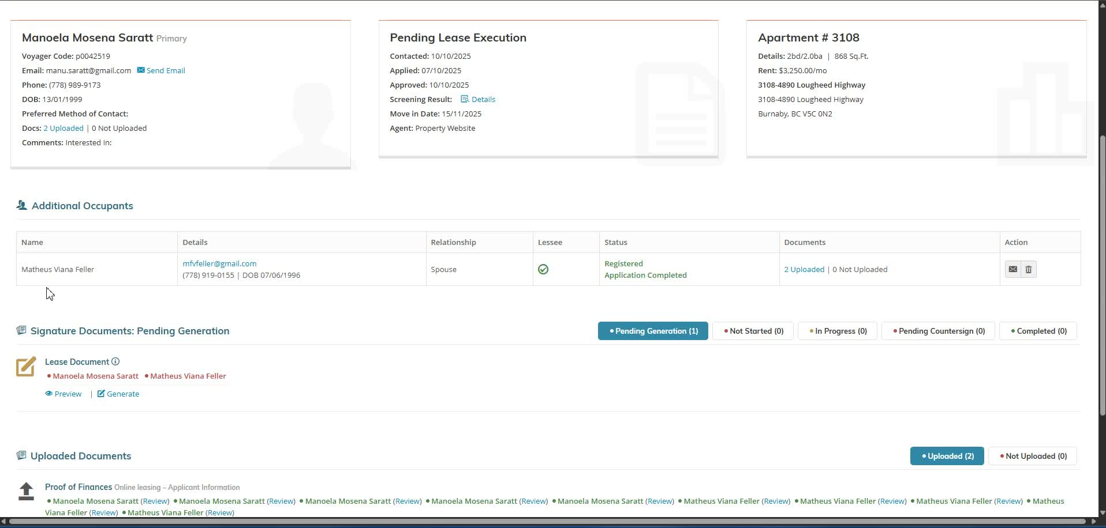
- Confirm that all necessary information is present before generating the tenancy agreement.
12. Review Prorated Rent and Payments 4:01
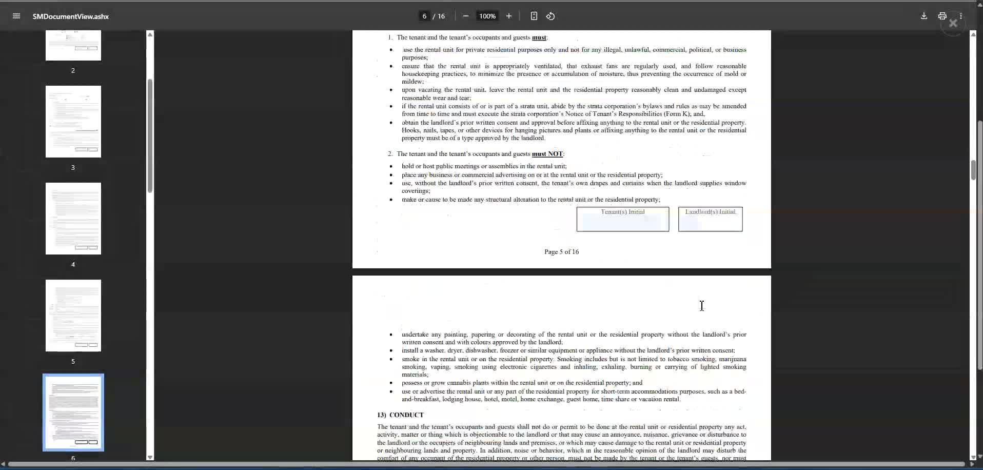
- Check for any prorated rent and ensure payment details are accurate.
13. Verify Additional Agreements 4:12
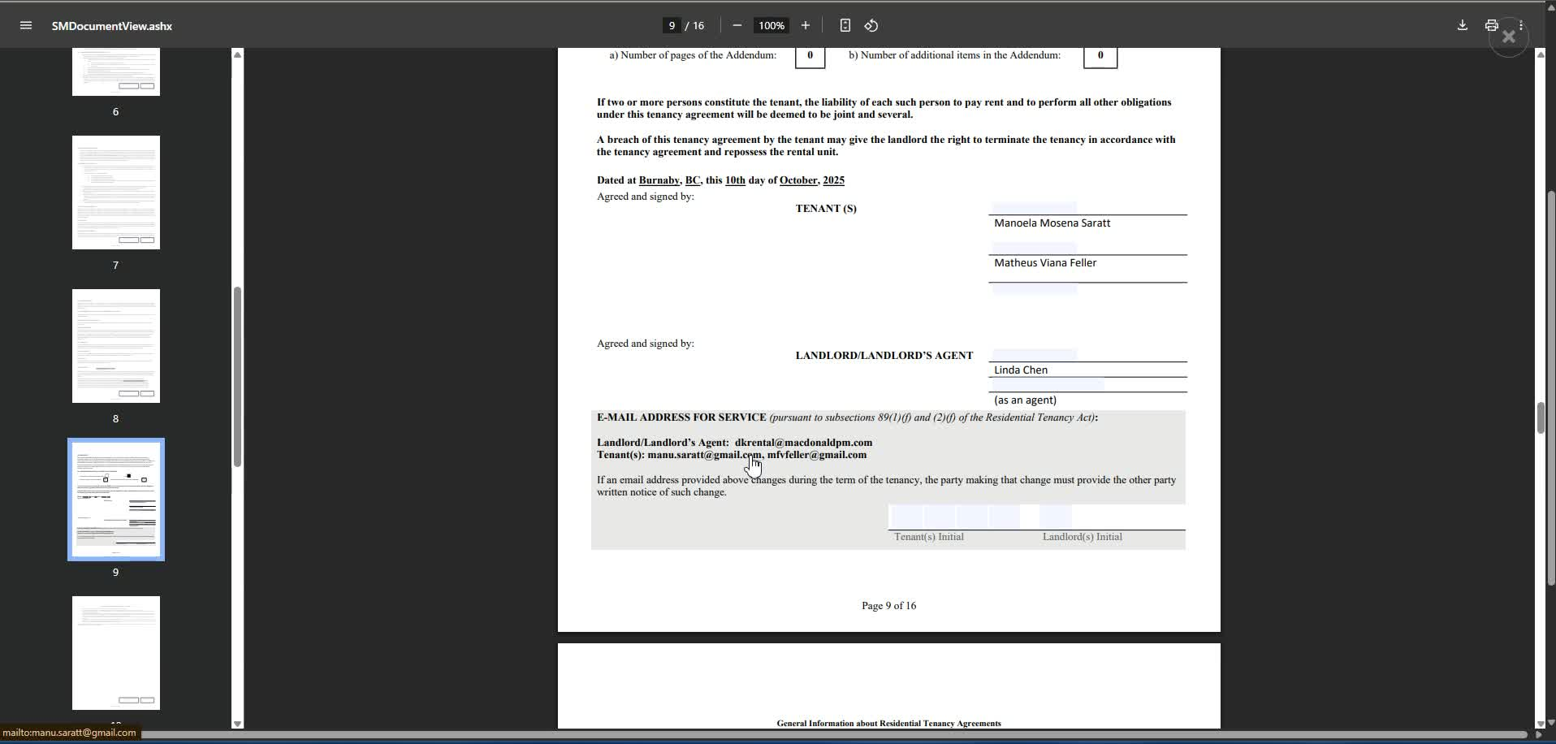
- Double-check emails and contact information.
- Review parking and storage locker agreements.
14. Finalize and Save Documents 4:50
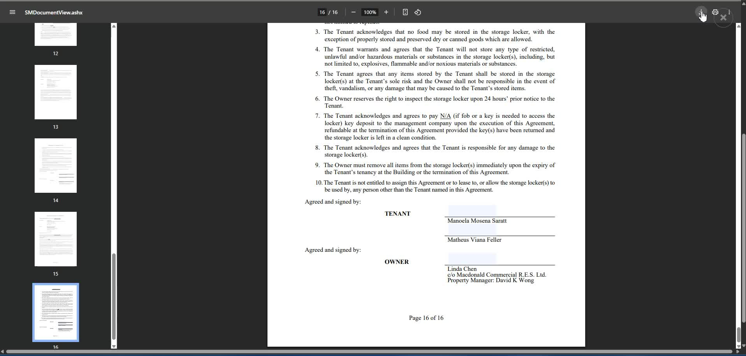
- Save all documents in the appropriate subfolder.
- Clean up documents before sending them off for signature.
Link to Loom
https://loom.com/share/d0b7b718db7b45a1a4c7c500ff9cdaff

Steps to Reproduce the Bug in Yardi Software

1. Access the Prospect Page 0:21
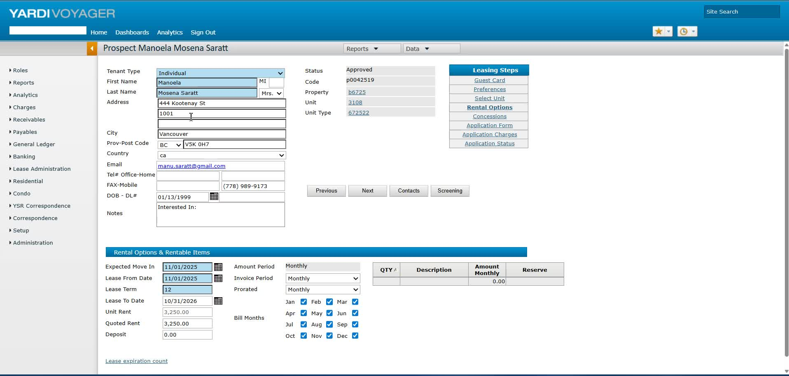
- Navigate to the home page of the Yardi software.
- Go to the Prospect page.

2. Check Pending Applications 0:42

- Go to the Pending Applications section.
- Ensure that the tenancy agreement has not been generated yet.

3. Select Rental Options 0:54

- Click on the 'Rental Options' section.
- Verify that the expected move-in date is set to November 15th.

4. Set Lease Dates 1:06
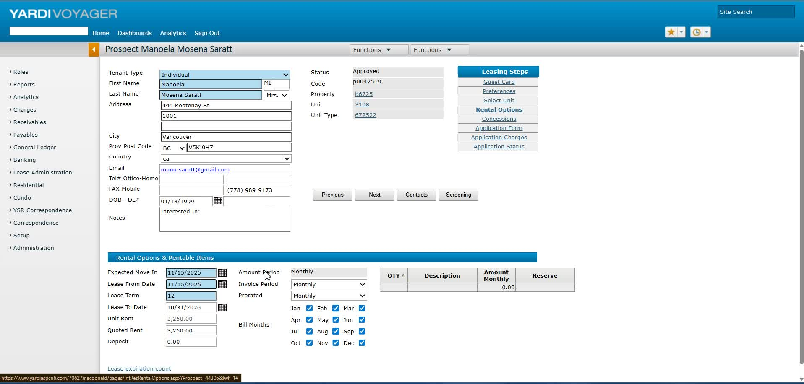
- Confirm that the lease date is set from November 15th to November 30th.

5. Review Application Charge 1:59

- Check the application charge details.
- Ensure that all information is correct before generating the tenancy agreement.

6. Verify Phone Numbers 2:16

- Check that the phone numbers are correctly displayed.
- Note that mobile numbers may not show up due to a glitch.

7. Save Changes 3:04

- Save any changes made to the application.
- Ensure that all tenant information is correctly saved.

8. Access RENCAFE 3:18

- Navigate to the RENCAFE section for the tenant's profile.
- Confirm that the move-in date has updated to November 15th.

9. Generate Tenancy Agreement 3:36

- Generate the tenancy agreement.
- Ensure that all details, including phone numbers and prorated rent, are correct.

10. Final Review 4:12

- Double-check all emails and contact information.
- Ensure all agreements (parking, storage locker) are ready for signature.
Link to Loom
https://loom.com/share/d0b7b718db7b45a1a4c7c500ff9cdaff

